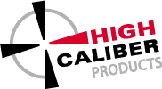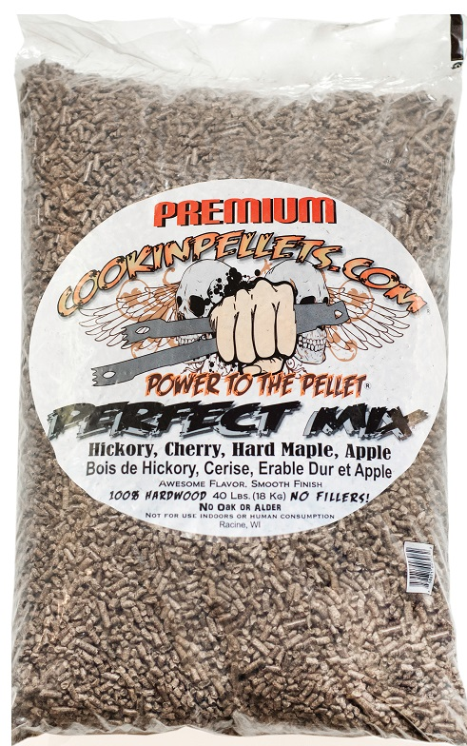

**Cookinpellets.com**

Use with any Pellet Grill!

**Introducing Cookin’Pellets! # P19CP00306**

Exclusive Premium mix of the most popular hardwoods used today:

Combination of Hickory, Cherry, Hard Maple & Apple

**NO Oak or Alder filler**

Making it great on short cooks and smooth smoke flavor on long smokes, not as heavy as all Hickory and not as light as Apple.

**Just 100% top Hardwoods!**

**No Filler | Low Moisture | Low Fine, Dust | High BT**

Reg. Price $ 45.00 / 40 lb bag

Now only $ 40.00 / 40 lb bag

We have done our research

to get you the best PELLET!